**WEEK 6– MORE QUERIES ON EMPLOYEE DATABASE**

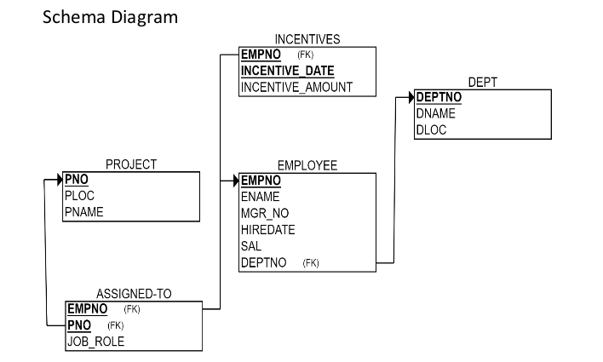

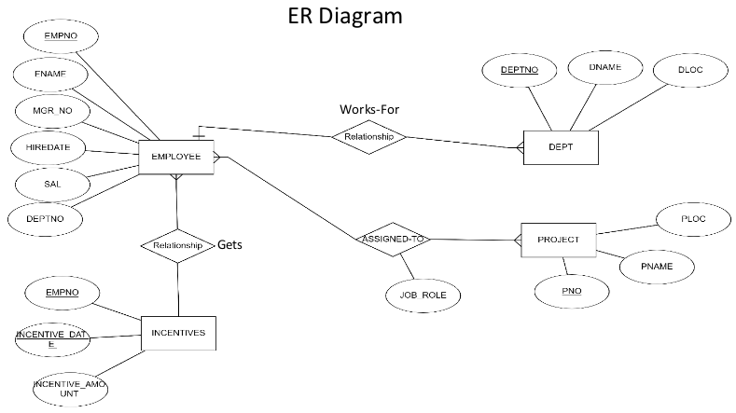

**TO DO:**

1. **Using Scheme diagram, Create tables by properly specifying the primary keys and the foreign keys.**

**(CREATION)**

create database dhiksha_employee;

use dhiksha_employee;

create table dhiksha_employee.project(

pno int,

ploc varchar(40),

pname varchar(40),

PRIMARY KEY(pno)

);

create table dhiksha_employee.dept(

deptno int,

dname varchar(40),

dloc varchar(40),

PRIMARY KEY(deptno)

);

create table dhiksha_employee.employee(

empno int,

ename varchar(40),

mgr_no int,

hiredate date,

sal int,

deptno int,

primary key (empno),

foreign key (deptno) references dept(deptno)

);

create table dhiksha_employee.incentives(

empno int,

incentive_date date,

incentive_amount int,

primary key(incentive_date),

foreign key (empno) references employee(empno)

);

create table dhiksha_employee.assigned_to(

empno int,

pno int,

job_role varchar(50),

foreign key (pno) references project(pno),

foreign key (empno) references employee(empno)

);

1. **Enter greater than five tuples for each table.**

**(INSERTION)**

insert into project values(1,"Bengaluru","Syntax");

insert into project values(2,"Gujurat","Rolex");

insert into project values(3,"Mysuru","Hybrid");

insert into project values(4,"Hyderabad,","Synergy");

insert into project values(5,"Mumbai","Mercury");

insert into project values(6,"Kerela","Innovation");

insert into dept values(10,"Sales","Bengaluru");

insert into dept values(20,"Finance","West Bengal");

insert into dept values(30,"Marketing","Bihar");

insert into dept values(40,"Purchase","Mumbai");

insert into dept values(50,"Research & Development" ,"Hyderabad");

insert into dept values(60,"Technical","Kerela");

insert into employee values(100,"Prannay",700,'2003-01-01',24000,10);

insert into employee values(200,"Farhaan",100,'2004-02-02',17000,50);

insert into employee values(300,"Sanika",100,'2003-01-21',9000,30);

insert into employee values(400,"Sakshi", 300 ,'2008-02-17',12000,40);

insert into employee values(500,"Nishith",400,'2004-03-05',3000,40);

insert into employee values(600,"Sohan",100,'2005-11-01',2000,20);

insert into employee values(700,"Mahima",NULL,'2005-11-21',8000,20);

insert into incentives values(100,'2019-02-17',6000);

insert into incentives values(200,'2019-05-21',7000);

insert into incentives values(400,'2012-07-25',6500);

insert into incentives values(500,'2019-04-19',7400);

insert into incentives values(600,'2013-08-08',8000);

insert into incentives values(700,'2019-08-08',8000);

insert into assigned_to values(100,1, "Project Manager");

insert into assigned_to values(200,1, "Resource Manager");

insert into assigned_to values(300,2, "Business Analyst");

insert into assigned_to values(400,3, "Business Analyst");

insert into assigned_to values(500,3, "Project Manager");

insert into assigned_to values(600,5, "Resource Manager");

* **SELECTION**

select * from project;

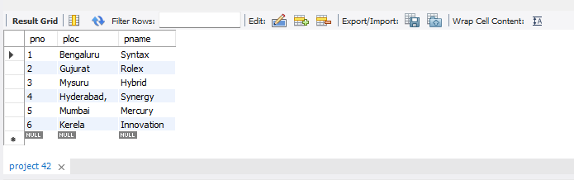

select * from dept;

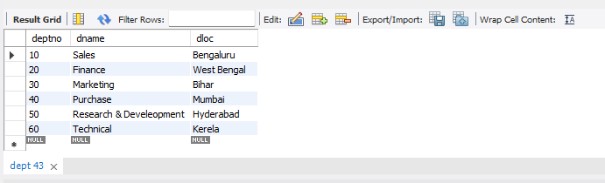

select * from employee;

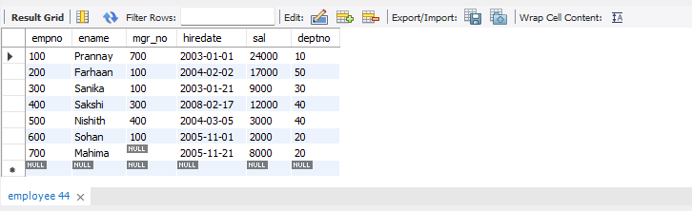

select * from incentives;

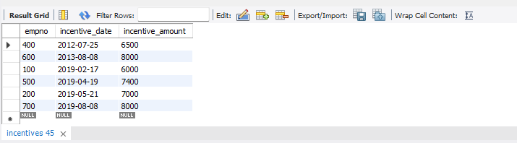

select * from assigned_to;

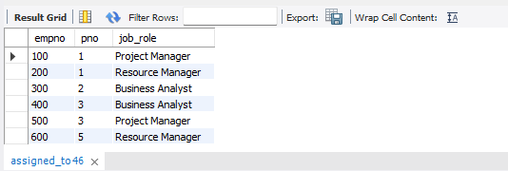

1. **List the name of the managers with the maximum employees**

select e1.ename

from employee e1, employee e2

where e1.empno=e2.mgr_no group by e1.ename

having count(e1.mgr_no)=(select count(e1.ename)

from employee e1, employee e2 where e1.empno=e2.mgr_no

group by e1.ename order by count(e1.ename) desc limit 1);

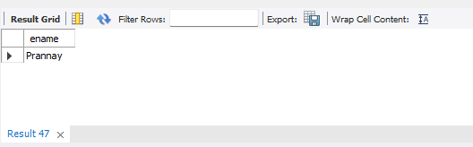

1. **Display those managers name whose salary is more than average salary of his**

select m.ename from employee m

where m.empno in

(select mgr_no from employee)

and m.sal>(select avg(n.sal) from employee n

where n.mgr_no=m.empno);

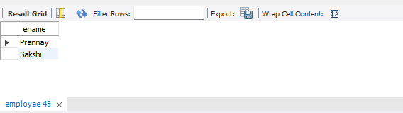

1. **Find the name of the second top level managers of each department.**

select ename from employee where empno in(select distinct mgr_no

from employee where empno in

(select distinct mgr_no from employee where empno in

(select distinct mgr_no from employee)));

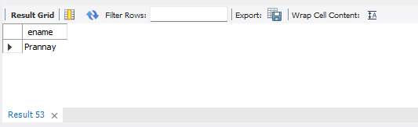

1. **Find the employee details who got second maximum incentive in January 2019.**

select * from employee where empno=

(select i.empno from incentives i

where i.incentive_amount= (select max(n.incentive_amount) from incentives n

where n.incentive_amount<(select max(inc.incentive_amount) from incentives inc

where inc.incentive_date between '2019-01-01' and '2019-12-31') and incentive_date between '2019-01-01' and '2019-12-31'));

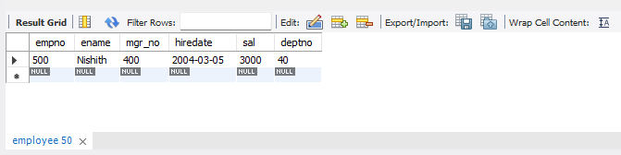

1. **Display those employees who are working in the same department where his manager is working.**

select e2.ename

from employee e1, employee e2

where e1.empno=e2.mgr_no and e1.deptno=e2.deptno;

